

Software Engineering Department
Ort Braude College

Capstone Project Phase A

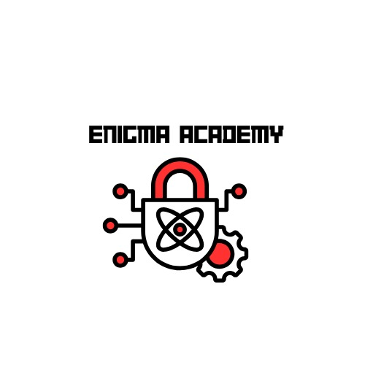
Enigma Academy

Advisor:
Moshe Sulamy

Team members:
Abed Ellateef Zoabi
Firas Amaria

Contents
- Introduction
- Related Work
  - Educational Games for Cryptography
    - CryptoClub
    - Cryptris
    - Cypher
  - Unity and Learning
  - Research on Game-Based Learning
  - Building on What Exists
  - Comparing Techniques and Outcomes
- BackGround
  - Cryptography
    - Types of Cryptographic Techniques
    - Cryptographic Tools We Will Focus On
    - Modern Applications of Cryptography
    - Key Concepts in Cryptography
  - Visual Learning
    - Visual Learning in Educational Games
    - Visual Learning Techniques we Used
    - Cognitive Benefits of Visual Learning
  - Unity Engine
    - 2D Game Development
    - Scripting and Logic
    - Community Support and Resources
- Expected Achievements
  - Outcomes
    - Learning While Playing
    - Gradual Learning
    - Real-World Skills
  - Unique Features
    - Wide Range of Topics
    - Timed Decryption Tasks
    - Track Your Progress
  - Criteria for Success
    - Keeping Players Interested
    - Game Runs Smoothly
    - Positive Feedback
- The Process
  - Research - Unity and Game Development
  - Methodology and Development Process
- Product
  - Requirements
    - Functional
    - Non-Functional
  - Architecture Overview
  - Scenes and Flow (Prototype)
  - Data storage
  - Diagrams
    - Use Case
    - Activity
    - Class
    - Sequence
- Verification And Evaluation
  - Verification
  - Evaluation
- References

Abstract

"Enigma Academy" is an innovative single-player, 2D game designed to demystify and teach cryptographic principles through interactive gameplay. Developed in Unity, this educational tool merges game-based learning with practical cryptographic scenarios to enhance user engagement and retention of complex concepts. Players progress through increasingly challenging puzzles, where they must decrypt messages using various cryptographic tools that they discover and learn to use within the game environment. Each puzzle integrates theoretical knowledge and practical application, ensuring that players not only understand but also apply their knowledge in simulated real-world scenarios. The game's unique approach includes a flexible inventory system where players can store and interact with texts and tools, a dynamic tutorial system that explains the functionality of each new tool in real time, and an achievement system that rewards players for their progress and mastery of cryptographic techniques. By the end of the game, players are expected to have a foundational understanding of key cryptographic methods and their applications, preparing them for further study or practical use in digital security.

1. Introduction

In today’s world, keeping information safe is more important than ever. Cryptography, the practice of encoding messages to keep them secret, is crucial for protecting personal information and national security. However, learning about cryptography can be complex and intimidating for many people.

"Enigma Academy" is designed to tackle this problem by turning the learning process into a fun, engaging game. This single-player, 2D experience created in Unity introduces players to the basics of cryptography through interactive puzzles and challenges. As players move through the game, they solve these puzzles using cryptographic methods, making the learning both practical and enjoyable.

The game is set up as a series of rooms, each representing a different level of cryptographic difficulty and teaching a specific concept. As players progress, they unlock new tools and face harder puzzles, which helps them understand and apply what they’ve learned in earlier stages. This method ensures that players not only remember the concepts but also know how to use them in different situations.

This introduction will explain how "Enigma Academy" was developed and how it uses gameplay to make complex ideas about cryptography easy to understand. The goal of the game is to make learning about cryptography accessible and interesting to everyone, helping players feel more confident about their understanding of this essential subject.

2. Related Work
The use of games to help people learn has become more popular, especially for teaching complex subjects like cryptography. This section looks at similar projects, exploring how they combine gaming with education and comparing their methods to what we're doing in "Enigma Academy”.
2.1 Educational Games for Cryptography
There are several games that teach players about cryptography, which is the art of making and breaking codes. For example, CryptoClub and Cryptris are games that introduce young learners to basic cryptographic techniques through fun puzzles and the challenge of uncovering secret messages. These games lay the groundwork for understanding more complicated concepts. "Enigma Academy" takes this a step further by offering more complex challenges and a variety of coding methods that cater not just to young learners but also to older students and adults.
2.1.1 CryptoClub
CryptoClub is designed for middle schoolers and focuses on basic cryptography through fun puzzles and games, making complex ideas like ciphers and encryption accessible and enjoyable. Enigma Academy, however, caters to a broader and possibly older audience, offering deeper insights into both basic and advanced cryptographic techniques through an immersive narrative-driven game that encourages practical application of learned concepts.
CryptoClub and Enigma Academy differ primarily in their target audiences and educational complexity. CryptoClub is geared towards middle school students, offering an introduction to basic cryptography and mathematics through a variety of simple, engaging games and activities. Its focus is on fundamental concepts like simple ciphers and basic encryption, making it highly accessible and suitable for younger learners.
On the other hand, Enigma Academy is designed for a broader audience that potentially includes older students and adults. It offers a more in-depth exploration of cryptographic principles, covering a wide range of topics from basic to advanced encryption techniques. The game integrates these concepts into a narrative-driven adventure, providing a more immersive and comprehensive learning experience that challenges players to apply their knowledge in practical, game-based scenarios.

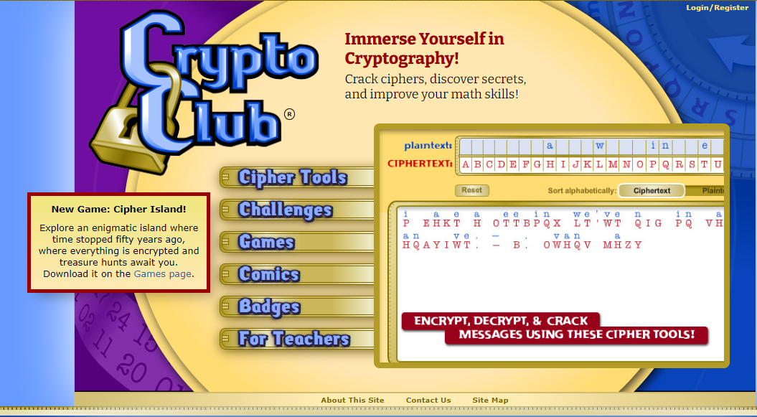

(CryptoClub homepage)
The homepage of CryptoClub, primarily functions as an educational portal rather than a standalone interactive game. It does not immediately immerse users in a game-like environment; rather, it serves as a gateway to various educational resources and activities. The site includes sections such as Cipher Tools, Challenges, Games, Comics, and Badges, but these are accessed individually rather than being integrated into a continuous game narrative or gameplay experience. They have downloadable games in the games section that you have to use cryptography in order to finish the game. Each game must be individually accessed and does not seamlessly connect with the other components offered on the homepage.
2.1.2 Cypher
Cypher is a first person puzzle game about cryptography. Explore the museum and learn about the history of cryptography, from simple substitution ciphers to the Enigma machine and beyond. Grab a pen and paper and test your deciphering skills across 40+ challenging puzzles.
This game teaches player old cryptography tools and how and why they were used , each room in the museum has different difficulty level so that player can start at the level they feel is appropriate for them .
"Cypher" focuses primarily on solving complex ciphers and codes within a puzzle-solving framework, often with an emphasis on historical encryption methods. It's designed mainly as a challenging puzzle game for those interested in cryptography, without a specific educational curriculum or progression through cryptographic concepts.
"Enigma Academy," on the other hand, is structured as an educational tool as well as a game. It offers a curriculum-based progression that teaches players cryptographic principles from basic to advanced levels, integrating these lessons into a narrative-driven adventure. This makes "Enigma Academy" not only a source of entertainment but also a comprehensive educational experience that systematically enhances the player’s understanding of cryptography.

 | 
From the gameplay image, it appears that the game feels more like participating in a classroom exercise or doing homework rather than engaging in traditional gameplay. Although the explanations within the game are clear and easy to understand, the gameplay lacks engaging elements that motivate players to solve the puzzles. This lack of stimulation may cause some players to lose interest and potentially stop playing, which would interrupt the learning process. This is a significant concern, especially when the primary goal is educational, and we aim to keep players engaged and learning continuously.

 | CryptoClub | Cypher | Enigma Academy
Target Audience | Middle school students, | Cryptography fans of all ages | Students
Educational Scope | Basic cryptography and mathematics. | Decoding complex historical ciphers. | Comprehensive cryptography, from basic to advanced levels.
Gameplay | Interactive games and puzzles focusing on simple cipher techniques | Puzzle-based gameplay centered on deciphering historical ciphers. | 2D Narrative-driven adventure integrating cryptographic puzzles within a progressive curriculum.
Complexity and depth | Simple and introductory, suitable for young beginners. | Moderately complex with a focus on historical depth in ciphers. | High complexity with extensive depth covering a wide range of cryptographic topics.
Learning outcomes | Introduces basic cryptography and mathematical problem-solving. | Enhances skills in pattern recognition and historical cipher decryption. | Provides a thorough understanding of cryptographic principles and their real-world applications.
2.2. Unity and Learning
Unity is a popular tool for making educational games because it allows developers to create detailed and interactive experiences. For instance, games like CodeCombat and LightBot use Unity to teach programming skills. They show that Unity is effective for making games that are not only fun but also educational. "Enigma Academy" uses Unity to create an engaging world where players can learn advanced cryptography through gameplay.
2.3. Research on Game-Based Learning
In the exploration of game-based learning, several pivotal works provide foundational insights into how digital games can enhance educational outcomes. James Paul Gee's seminal book, "What Video Games Have to Teach Us About Learning and Literacy" (2003), argues that video games are powerful learning tools that foster cognitive development through interactive engagement. Marc Prensky's "Digital Game-Based Learning" (2007) expands on this by discussing the integration of entertainment and education, proposing that digital games not only engage students but also enhance their learning experiences by making complex subjects more accessible and enjoyable. Additionally, Douglas B. Clark et al. in their systematic review and meta-analysis "Digital Games, Design, and Learning" (2016), provide empirical evidence supporting the effectiveness of game design in educational settings, emphasizing that well-designed games can significantly boost learning outcomes. These sources collectively underscore the transformative potential of game-based learning in educational contexts, suggesting that when thoughtfully designed, games can be powerful tools for educational enhancement and student engagement.
In their comprehensive study, "Digital Games, Design, and Learning: A Systematic Review and Meta-Analysis," Douglas B. Clark and colleagues aimed to assess the educational effectiveness of digital games compared to traditional learning methods. The study involved a meta-analysis of various research findings that measured the learning outcomes, engagement, and motivation levels of students who used educational games against those who employed conventional learning approaches. Their findings indicated that digital games significantly enhance learning outcomes when properly designed to align with educational goals. This impact was most notable in how games increased student engagement and motivation, critical factors that contribute to effective learning. The study highlighted the importance of thoughtful game design, emphasizing that the educational benefits of games depend heavily on how well their gameplay mechanics and narrative elements integrate with intended learning objectives.

2.4. Building on What Exists
While many educational games focus on basic skills and are meant for children, there's a need for games that teach more advanced skills to older learners. Most existing games do not cover the depth of content or the real-life applications that "Enigma Academy" does. Our game fills this gap by providing a challenging and comprehensive learning experience that helps players not only learn but also apply cryptographic skills in scenarios that mimic real-life situations.
2.5. Comparing Techniques and Outcomes
When we compare "Enigma Academy" to other educational games, it stands out because of its depth and focus on practical skills. Most games are limited to simple puzzles and basic coding tasks. In contrast, "Enigma Academy" integrates real cryptographic challenges into its gameplay, making it a unique tool for learning. This approach is designed to prepare players for using cryptography in real situations, enhancing both their understanding and ability to apply what they've learned.

3. Background
this section is dedicated for the description of term ,algorithms and methods used in this project
3.1. Cryptography
Cryptography is the science of securing communication through encoding and decoding information. It ensures the confidentiality, integrity, and authenticity of sensitive data, protecting it from unauthorized access. From the ancient Caesar Cipher to the sophisticated algorithms used in modern encryption, cryptography has evolved significantly to meet the demands of secure communication. Today, it plays a vital role in securing online transactions, protecting personal information, and ensuring data privacy.

3.1.1. Types of Cryptographic Techniques
Cryptographic techniques can be categorized into the following types:
1. Substitution Ciphers:
    - Replace each letter in the plaintext with another letter based on a specific rule.
    - Examples:
      - Caesar Cipher: Letters are shifted by a fixed number of positions.
      - Monoalphabetic Cipher: A more complex substitution where each letter maps to a unique replacement.
2. Transposition Ciphers:
    - Rearrange the order of characters in plaintext without altering the letters themselves.
    - Examples:
      - Rail Fence Cipher: Text is written in a zigzag pattern and read row by row.
      - Columnar Transposition Cipher: Text is written into rows and read by columns based on a keyword.
3. Polyalphabetic Ciphers:
    - Use multiple substitution alphabets to encrypt the message.
    - Examples:
      - Vigenère Cipher: Employs a keyword to define shifts for each letter.

4. Modern Cryptographic Techniques (Not used in the game but noteworthy):
    - Symmetric Encryption: Uses the same key for both encryption and decryption (e.g., AES).
    - Asymmetric Encryption: Uses a public-private key pair for secure communication (e.g., RSA).

3.1.2. Cryptographic Tools We Will Focus On
In "Enigma Academy," players will use the following tools to solve cryptographic puzzles:
- Caesar Cipher:
  - A simple substitution cipher where letters are shifted by a fixed number.
  - Introduces players to basic encryption and decryption concepts.
- Rail Fence Cipher:
  - A transposition cipher that demonstrates the rearrangement of letters in a zigzag pattern.
  - Encourages players to think critically about letter placement.
- Vigenère Cipher:
  - A polyalphabetic substitution cipher that uses a keyword for encryption.
  - Highlights the importance of keys in cryptography.

3.1.3. Modern Applications of Cryptography
Cryptography is an essential component of modern technology, with applications such as:
- Secure Communication: End-to-end encryption in messaging apps like WhatsApp and Signal.
- Online Transactions: Protecting sensitive information during online purchases with SSL/TLS.
- Blockchain Technology: Ensuring data integrity and security in cryptocurrency systems.
- Authentication: Verifying identities with digital signatures and certificates.
These applications underscore the real-world relevance of cryptographic techniques, connecting the educational goals of "Enigma Academy" to practical uses.

3.1.4. Key Concepts in Cryptography
Keys: A key is used to encrypt and decrypt data. It can be shared (symmetric) or kept private (asymmetric).
Plaintext and Ciphertext: Plaintext is the original message, while ciphertext is the encrypted version.
Encryption and Decryption: Encryption secures data, and decryption restores it to its original form.
Algorithms: Mathematical formulas used to transform plaintext into ciphertext and vice versa.

3.2. Visual Learning
Visual learning emphasizes using images, diagrams, animations, and interactive tools to enhance comprehension and retention. It is particularly effective for students who struggle with abstract concepts, as it simplifies complex ideas into tangible visuals. Studies show visual learning improves retention and fosters critical thinking by encouraging interaction with visual data. In "Enigma Academy," this approach is central, as players solve cryptographic puzzles through immersive and visually guided gameplay.

3.2.1. Visual Learning in Educational Games
Educational games effectively utilize visual learning by combining interactive elements with engaging visuals. Games can simplify challenging subjects by using animations, progress trackers, and interactive feedback systems. For instance, puzzles and real-time demonstrations help break down complex concepts into manageable steps.
In "Enigma Academy," visual learning is integrated into the gameplay to teach cryptographic principles interactively. Players observe real-time transformations as they apply tools to encrypted texts, enhancing their understanding of the decryption process. This combination of visual feedback and hands-on engagement ensures that learning feels natural and enjoyable.

3.2.2. Visual Learning Techniques we Used
Interactive Gameplay:
- Players interact with glowing objects, inventory items, and puzzle-solving interfaces. This visual guidance draws attention to important elements, ensuring clarity during gameplay.
Dynamic Inventory System:
- The inventory resembles an open book, where encrypted and decrypted texts are displayed side by side. Players can visually compare results after applying tools, reinforcing their understanding of cryptographic methods. Players are able to save any text they find in the game , they can even save decrypted texts after they use the cryptography tools in the inventory .
Puzzle Interfaces:
- Each puzzle offers a unique visual design, allowing players to experiment with tools like the Caesar Cipher or Vigenère Cipher. The interface provides immediate feedback, showing how each tool transforms the text.

3.2.3. Cognitive Benefits of Visual Learning
Visual learning stimulates cognitive functions such as problem-solving, critical thinking, and creativity. By encouraging players to experiment with cryptographic tools in a visually guided environment, "Enigma Academy" fosters active learning and exploration. The ability to observe and manipulate data interactively helps players build connections between cryptographic principles and real-world applications, making the educational experience both immersive and impactful.
3.3. Unity Engine
Unity is a cross-platform game engine widely used for developing 2D and 3D games. Known for its flexibility and robust feature set, Unity provides tools for physics simulation, scripting, and asset management, making it an ideal choice for creating educational games.

3.3.1. 2D Game Development
Unity’s 2D capabilities allow for the creation of top-down room layouts, character movement, and interactive objects. This simplifies the development of environments and gameplay mechanics.

3.3.2. Scripting and Logic
The engine’s scripting capabilities, powered by C#, enable the implementation of complex systems like dynamic inventory, puzzle validation, and room transitions. Unity’s modular architecture ensures that these systems are scalable and maintainable.

3.3.3. Community Support and Resources
Unity's asset store provides access to pre-built components and assets, accelerating the development process. Additionally, the extensive community support ensures developers have access to tutorials, forums, and tools, which are invaluable for resolving challenges and expanding the game.
4. Expected Achievements
4.1. Outcomes
"Enigma Academy" isn't just a game; it's a journey into the world of cryptography where players learn crucial security skills through engaging and interactive gameplay. Our goal is to transform how players think about and understand cryptography, making it accessible and enjoyable for everyone, whether they are new to the topic or looking to deepen their knowledge. Here’s how we plan to achieve these educational goals through the game:
4.1.1. Learning While Playing
The game simplifies complex concepts of codes and encryption, showing players how different encryption methods work. Each level is designed around a specific cryptographic technique, ranging from historical ciphers to modern-day encryption technologies, giving players a comprehensive learning experience.
4.1.2. Gradual Learning
The game is structured to progressively increase in difficulty, making it welcoming for beginners while still challenging for those with some background in cryptography. It starts with simple ciphers and gradually moves towards more complex topics like public-key cryptography and digital signatures, ensuring a smooth learning curve.
4.1.3. Real-World Skills
Beyond gameplay, "Enigma Academy" equips players with practical skills applicable in real-life scenarios. It teaches players how to protect their data and understand the mechanisms behind secure communications, integrating these skills through puzzles that mimic real-life challenges.
4.2. Unique Features
"Enigma Academy" offers several special features that make learning about cryptography engaging and effective:
4.2.1. Wide Range of Topics
The game teaches a variety of cryptographic techniques. Players start with simple methods like the Caesar Cipher and gradually learn more advanced techniques, including modern encryption methods used today. Each topic is introduced through puzzles that show how these techniques are used in real life.

4.2.2. Timed Decryption Tasks
There are special challenges where players need to decrypt messages quickly to solve urgent problems in the game. These tasks help players practice using their cryptographic skills under pressure, similar to real-life situations.
4.2.3. Track Your Progress
The game keeps track of how much players have learned and how well they are doing. Players earn badges and rewards as they master new skills and complete sections of the game, which encourages them to keep learning and improving.

4.3. Criteria for Success
To make sure "Enigma Academy" is successful and effective, we have set specific goals that the game needs to meet. Here are the key areas we will focus on:
4.3.1. Keeping Players Interested
The game should be fun and exciting so that players want to keep coming back. We'll make sure the puzzles are interesting and the story is engaging. Success in this area means players stay with the game until the end and possibly replay it.
4.3.2. Game Runs Smoothly
The game should work well on all types of devices, whether it's a computer, tablet, or smartphone. It should not crash or slow down. We'll test the game on many devices to make sure it's reliable and enjoyable for everyone.
4.3.3. Positive Feedback
We hope to hear good things from the people who play our game. Success would mean getting positive reviews and comments from players. We also hope to be recognized by educational groups or gaming communities for creating a game that is both fun and educational.

5. The Process
This section explains how we plan to create "Enigma Academy," focusing on how we will use the Unity game engine and build the game's educational content about cryptography.
5.1. Research - Unity and Game Development
Our exploration of the Unity engine began with a comprehensive review of game development principles and the necessary technical skills. We started with online tutorials that provided a basic overview of what Unity offers and how we can utilize its capabilities for game development. These tutorials were helpful for establishing a foundational understanding of the platform. These tutorials were important in guiding us through practical aspects of game development using Unity, such as creating scenes, managing interactions between game objects, manipulating the camera, and enhancing the efficiency of our layouts. This phase of research and learning has equipped us with a thorough understanding of Unity's functionalities and a solid skill set in game development, setting the stage for the efficient creation of "Enigma Academy”.
As we started using the Unity platform, we faced several challenges. The first big challenge was learning how to use all the features that Unity offers. We spent a lot of time on this to make sure we understood the basics well before moving on to actually making the game. We focused on learning these basics early because we knew we wouldn't have much time to learn them once we started building the game.
5.2. Methodology and Development Process
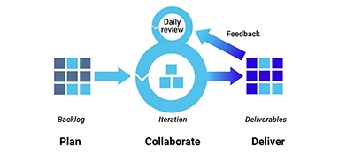
For "Enigma Academy," we chose Agile methodology because it suits our need for flexibility and regular updates based on what we learn from testing the game. Agile helps us adjust quickly and keep improving our game.
Development Steps:
- Building Game Scenes in Unity
- Adding Interactive Learning Features
- Tracking and Analyzing How Players Learn
- Storing Player Data Safely
- Regularly Updating Based on Player Feedback
- Making Sure Educational Content is Correct
- Designing User-Friendly Interfaces

Iterative Testing and Feedback:
Throughout the game development process, we'll test everything over and over. We'll get feedback from cryptography experts, teachers, and players, and use that information to make quick improvements for the next round of development.
Focus on Effective Delivery:
Our main goal is to deliver a game that effectively teaches cryptography while being engaging. We'll focus on making a game that improves based on feedback and testing, constantly evolving to meet educational goals better.

6. Product
6.1.Requirements
6.1.1. Functional
- The system must display guidance dialogs/tutorials when players discover new tools.
- The system allows the player to move and interact within a 2D room environment.
- The system allows players to apply decryption tools to any text in the inventory.
- The system provides feedback (e.g., correct or incorrect solutions) when players submit puzzle solutions.
- The system progresses players to the next room when a puzzle is successfully solved.
- The system allows players to revisit earlier rooms to solve puzzles using newly discovered tools.
- The system offers rewards and achievements, such as unlocking graduation attire, for completing puzzles.
- The system includes a history book feature that teaches the historical context of cryptographic tools.
- The system ensures all cryptographic puzzles increase in complexity, requiring critical thinking and iterative solutions.

6.1.2. Non-Functional
- The game must maintain smooth performance, even as the inventory grows or puzzles become more complex.
- The game must not crash during room transitions, inventory interactions, or puzzle submissions.
- The game must fulfill its educational purpose by teaching cryptography through interactive gameplay.
- The game must be engaging and enjoyable for players of all skill levels.
- The system must support multiple screen resolutions and input devices (e.g., keyboard and mouse).
- The game must provide an immersive academy-themed environment, with visually consistent rooms and UI.
- The system must ensure stable and secure storage of player progress, preventing data loss or corruption.
- The game must protect against unauthorized modifications, ensuring puzzles and inventory remain secure.
- Tutorials must dynamically integrate into the gameplay without disrupting player immersion.
- The game must support scalability to allow future expansions, such as additional rooms or advanced cryptographic tools.
6.2. Architecture Overview
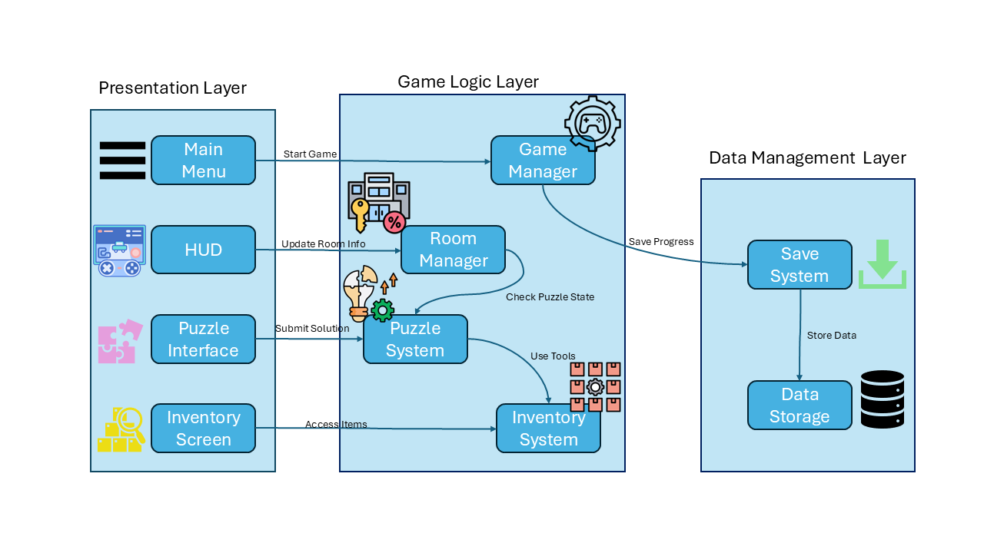
1. Presentation Layer (User Interface & Interaction)
The Presentation Layer is responsible for how the player interacts with the game. It includes:
Main Menu
  - The starting screen where players can start, load, or exit the game.
  - Contains options like settings and game instructions.
HUD (Heads-Up Display)
  - Displays useful gameplay information.
  - Could include indicators like room number, puzzle progress, or available cryptographic tools.
Puzzle Interface
  - The screen where players interact with puzzles.
  - Displays encrypted text and available decryption tools.
Inventory Screen
  - Shows collected tools and saved texts.
  - Players can access and apply decryption tools to stored texts.

2. Game Logic Layer (Core Mechanics & Game State Management)
This layer handles the game’s mechanics and logic, ensuring proper functionality and tracking player progress.
Game Manager
  - The central controller that oversees the entire game.
  - Manages game start, transitions between rooms, and overall player progression.
Room Manager
  - Controls the room state, tracks which puzzles have been solved, and updates room information.
  - Ensures smooth transition between rooms.
Puzzle System
  - Handles the logic behind puzzles.
  - Checks if the player's decryption attempt is correct.
  - Communicates with the Room Manager to update room progress.
Inventory System
  - Manages the player's collected tools and stored texts.
  - Allows players to apply decryption tools to stored texts.
  - Ensures the Puzzle System can access necessary tools.

3. Data Management Layer (Saving & Storing Game Data)
This layer handles saving and loading player progress.
Save System
  - Stores and retrieves game data.
  - Saves player progress, puzzle completion, and inventory contents.
  - Ensures data persistence between sessions.
Data Storage
  - The backend storage system (e.g., JSON files, SQLite database, or game cache).
  - Stores encrypted texts, player progress, and collected tools.

6.3. Scenes and Flow (Prototype)
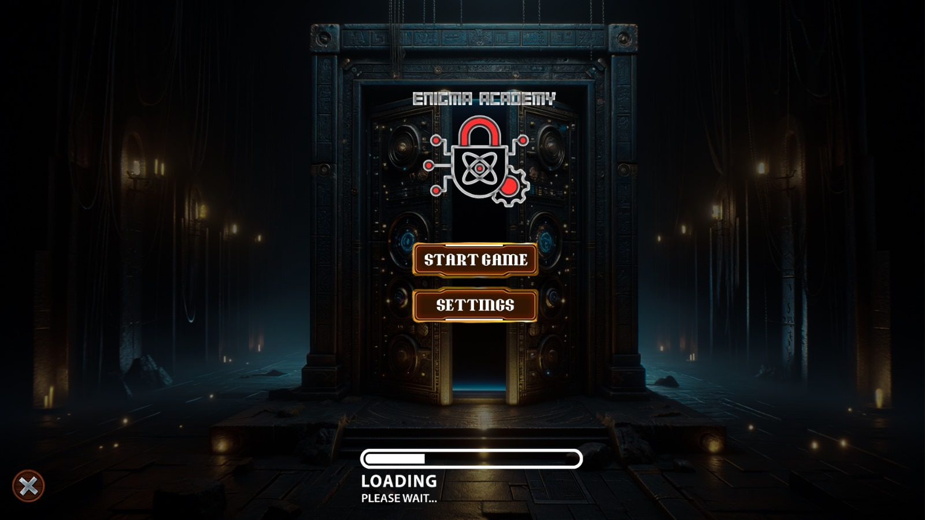
Main Menu
In the main menu you will be able to start the game or access the settings , there you can change the basic gameplay settings (sounds , screen size , etc) .or exit the game (on the left bottom side).

Puzzle Room
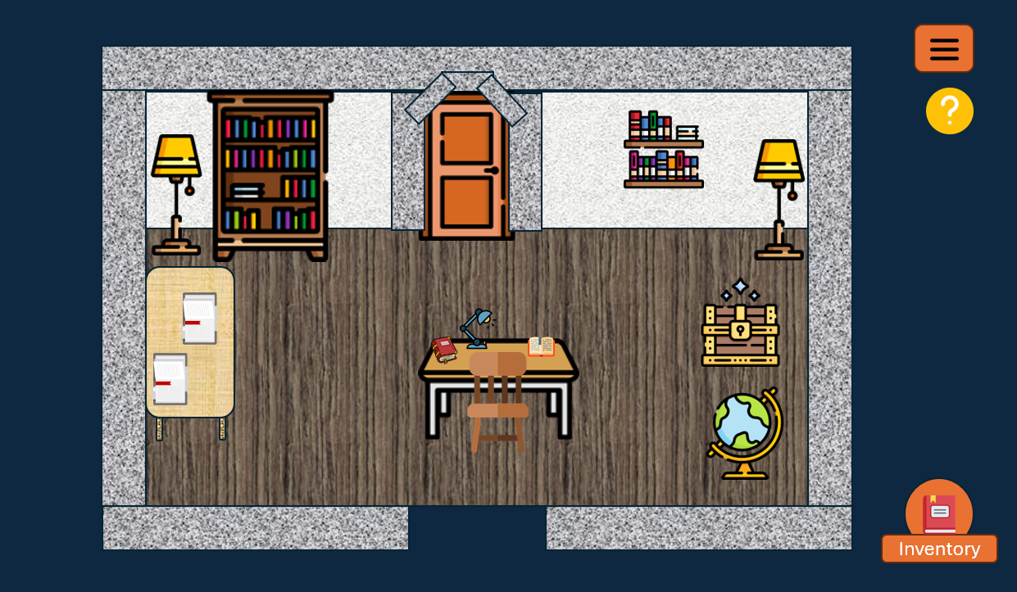
Here is how the puzzle Rooms would generally look like , there will be random selection of items the player can interact with (Bookshelves ,tables , drawers , boxes,etc) in this room he will find text and clues and even crypto Tools that will help them in opening the locked door that leads to the next puzzle , each room would have a different difficulty level which would go up with each room . another important note is we are planing to make the rooms connected so that even a hint that was found in the later rooms can be used in the rooms before it .

inventory screen
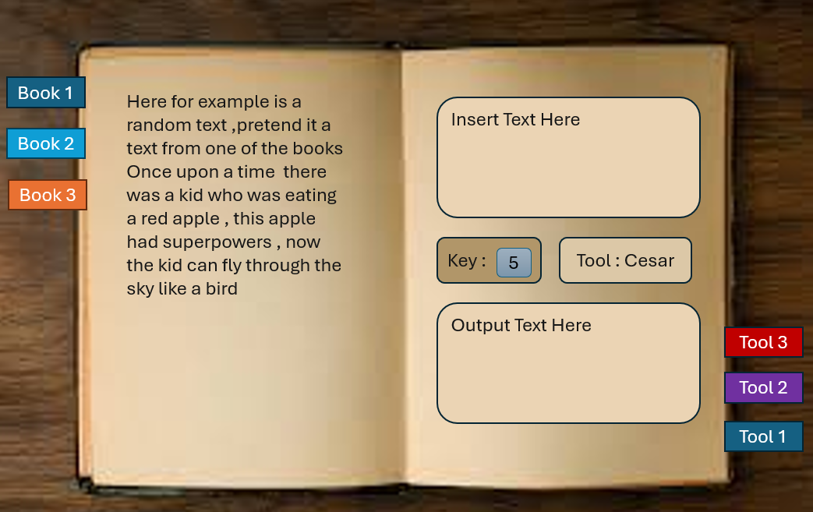
Here we have an example of the inventory screen , on the left side would be the saved text page , there we can view all of the texts and books we found throughout the game and are able to access them and read them at any time , on the right side is the Crypto Tools page , this side would include the Tools that we unlocked as bookmarks , when open we will have the option to copy part of the text that we have open on the left side and we will get the result of using the crypto Tool on the text , the result would change with each text and each tool used . of course decrypted text can also be saved into the inventory and again be used as any other text in the game.

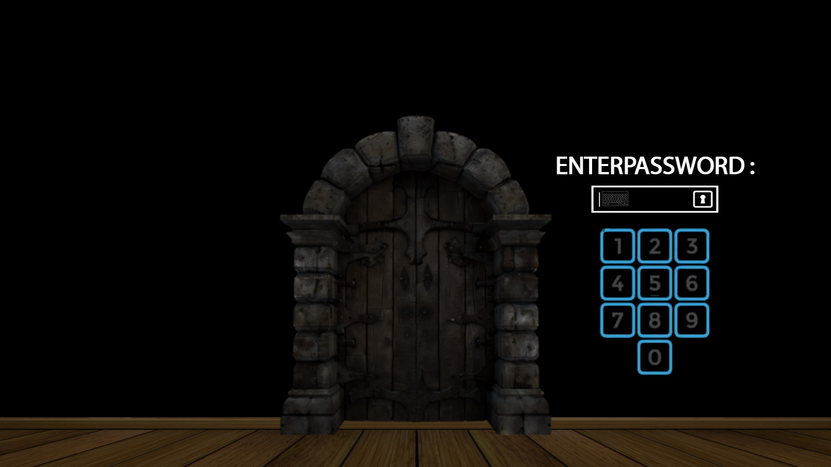
door puzzle screen
Here is an example of the door screen where the player would need to enter the password they found (note: this could also include characters and not only numbers) .

6.4. Data storage
In our game we will be using local Data to save the player progress , this will include , what room the player is in , what puzzles they solve , what tools they unlocked and the text that are saved in the inventory
6.5. Diagrams
6.5.1. Use Case
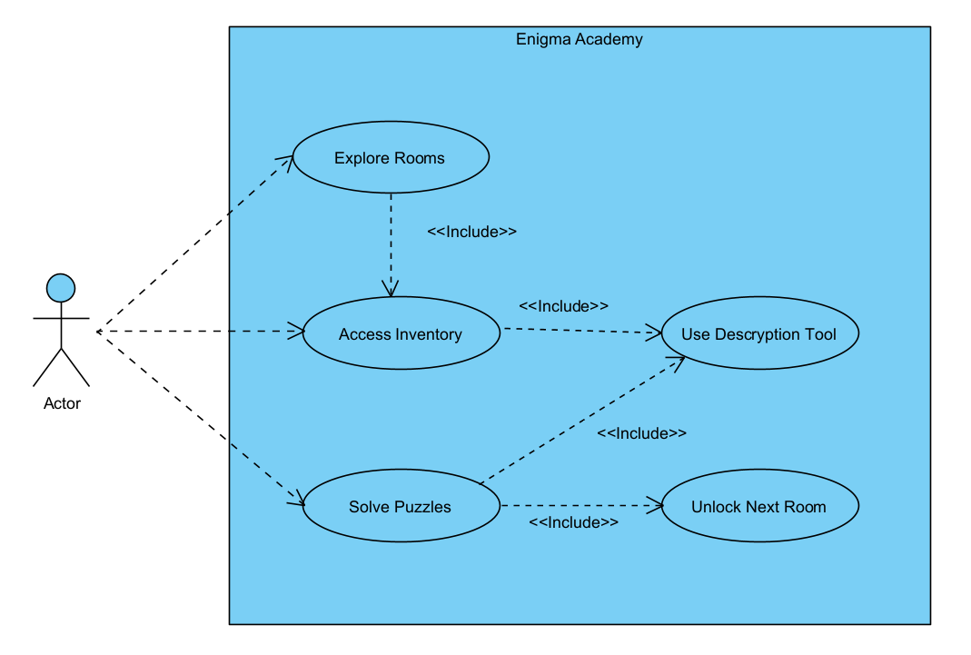
6.5.2. Activity
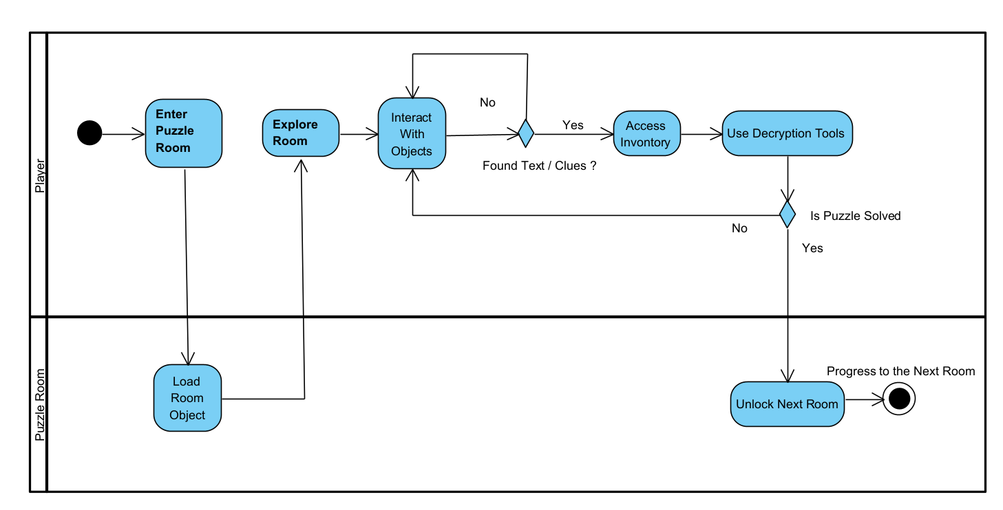
6.5.3 Class
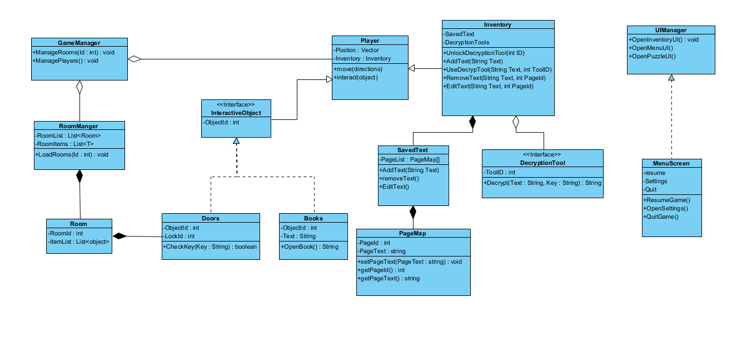
6.5.4. Sequence
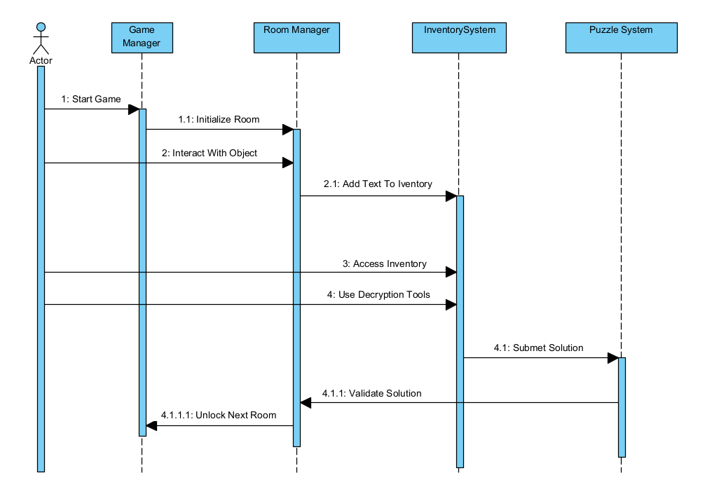
7. Verification And Evaluation
A successful implementation of verification and evaluation in "Enigma Academy" is essential for ensuring that the game meets both its technical standards and educational goals. Verification processes such as code reviews and performance checks will ensure that the game functions flawlessly and remains free from defects. Meanwhile, evaluation methods like playtesting and surveys will assess the educational effectiveness and engagement levels of the game. Together, these processes will enable continuous improvements, ensuring "Enigma Academy" is both a compelling and educational experience. By integrating these critical steps into the development cycle, we aim to create a game that not only entertains but also effectively teaches cryptography to its players.
7.1 Verification
verification is a process used to ensure that the game is accurately developed according to the specified requirements. It's essentially about checking if the software was built right and meets the predefined specifications set out during the planning and design stages.For “Enigma Academy” we are going to use Unity Test Framework. The Unity Test Framework (UTF) enables Unity users to test their code in both Edit Mode and Play Mode, There are two main categories of tests you can write with UTF, Edit mode and Play mode:
- Edit mode tests run in the Unity Editor and have access to both Editor and game code. This means you can test your custom Editor extensions or use tests to modify settings in the Editor and enter Play mode, which is useful for adjusting Inspector values and then running automated tests with many different settings.
- Play mode tests let you exercise your game code at runtime. Tests are generally run as coroutines using the [UnityTest] attribute. This allows you to test code that can run across multiple frames. By default, Play mode tests will run in the Editor, but you can also run them in a standalone player build for various target platforms.
overview of the types of testing UTF supports:
- Unit testing: Unit testing is a technique that involves testing individual units or components of a game in isolation, helping to ensure bugs are caught early in the development process and that changes to the code don’t break existing functionality. Unit testing is done by writing small test cases that exercise specific behaviors of the code. Tests can be run on individual scripts, GameObjects, or specific features of the game.

- Test-driven development (TDD): TDD is a technique that involves writing tests for a piece of functionality before writing the actual code to implement it. The process usually involves writing a failing test, writing the minimum amount of code necessary to make the test pass, and then refactoring the code to make it more maintainable before moving on to design the next test case.
- Integration testing: Integration testing is a technique that tests different components of a system together to ensure they work correctly. This can include testing how different GameObjects, scripts, or systems interact with one another within the game. Due to its wider scope, integration testing can help catch bugs that may not show up in unit testing, such as problems with data flow or communication between components. For example, instead of using individual unit tests, an integration test could be written for this entire sequence: a player firing a weapon which instantiates a bullet, the bullet hitting an enemy and killing them, the player getting points for killing the enemy, and an achievement being unlocked when the player reaches a certain score.
- Regression testing: Regression testing is a method to verify that software or features perform correctly after being modified or updated. The goal of regression testing is to ensure that changes to the codebase do not introduce new bugs or regressions in the software. This technique is best applied to large, complex applications with frequent updates, such as a live game, where there may be many different components that can interact in unexpected ways. As your game world and mechanics expand, so does the need for regression testing, which can make it costly. Therefore, it’s important to automate it wherever possible. Regression testing should be done in parallel with the development of new features, especially if you’re targeting multiple platforms.
- Functional testing: Functional testing evaluates the functionality of a system or software application by testing it against its functional requirements. It involves testing the system’s features, user interfaces, database interactions, and other aspects that affect its behavior and functionality. The objective of functional testing is to verify whether the system or application meets the requirements and specifications provided by the customer or end user.
- Performance testing: Performance testing involves testing the game to ensure that it runs smoothly and efficiently on different hardware and software configurations. This is closely related to profiling and general performance optimization workflows, and this practice can help identify performance bottlenecks or issues that may impact the game’s performance. The key objective is to evaluate the performance of a system or application under different workload conditions. In game development, performance testing gauges whether the game runs at an acceptable level of performance, frame rate, responsiveness, and stability, and uses memory most efficiently.
7.2 Evaluation
Game evaluation is a systematic process used to assess various aspects of a video game's design, functionality, usability, and overall player experience. This process is essential to ensure that the game meets its intended objectives, whether they are entertainment, education, or a combination of both. Evaluation factors that have to be considered:
- Playability: The games have good playability if they are easy to use, and are challenging and fun. High playability is crucial as it directly impacts a player's desire to continue playing and revisiting the game.
- Usability: Game usability focuses on how easily players can learn and interact with the game. It includes the intuitiveness of the user interface, the clarity of game controls, and how effectively the game communicates necessary information to the player. Usability is key to ensuring that players can fully engage with the game without frustration.
- Quality: Game quality assesses the overall excellence of the game, including technical performance, absence of bugs, and alignment with design specifications. High-quality games provide a seamless experience that is free from disruptions like crashes or glitches, contributing to player satisfaction and the game's reputation.

8. References

- CryptoClub Project. (n.d.). About the project. Retrieved from https://cryptoclubproject.uchicago.edu/about/about-the-project
- https://store.steampowered.com/app/746710/Cypher/
- James Paul Gee. "What Video Games Have to Teach Us About Learning and Literacy." Palgrave Macmillan, 2003.

- Marc Prensky. "Digital Game-Based Learning." Paragon House, 2007.

- Squire, Kurt. "Video Games in Education: Why They Should Be Used and How They Are Being Used." Journal of Educational Multimedia and Hypermedia, 2003.

- Clark, D. B., Tanner-Smith, E. E., & Killingsworth, S. S. (2016). Digital games, design, and learning: A systematic review and meta-analysis. Review of Educational Research, 86(1), 79-122.

- Unity Technologies. "Education Through Interactive 3D." Unity Technologies, [Year].
- https://cryptoclubproject.uchicago.edu/about/about-the-project

- Michael, David, and Chen, Sandra. "Serious Games: Games That Educate, Train, and Inform." Muska & Lipman/Premier-Trade, 2005.

- Shaffer, David Williamson. "How Computer Games Help Children Learn." Palgrave Macmillan, 2006.

- https://docs.unity3d.com/Packages/com.unity.test-framework@1.4/manual/index.html

- https://unity.com/how-to/automated-tests-unity-test-framework

- https://web.archive.org/web/20240415020832/https://docs.unity3d.com/ScriptReference/Coroutine.html
- https://unity.com/how-to/testing-and-quality-assurance-tips-unity-projects
- https://unity.com/resources/ultimate-guide-to-profiling-unity-games
- International Organization for Standardization. (2011). Systems and software engineering — Systems and software quality requirements and evaluation (SQuaRE) — System and software quality models (ISO/IEC 25010:2011). https://www.iso.org/standard/35733.html
- Bernhaupt, R. (Ed.). (2010). Evaluating user experience in games: Concepts and methods. Springer. https://link.springer.com/book/10.1007/978-1-84882-963-3
- Fullerton, T. (2014). Game design workshop: A playcentric approach to creating innovative games (3rd ed.). CRC Press. https://www.routledge.com/Game-Design-Workshop-A-Playcentric-Approach-to-Creating-Innovative-Games/Fullerton/p/book/9781482217162

